**STEPS TO UPDATE ALL YOUR CERTIFICATIONS DETAILS IN THE CERTRAK TOOL :**

Step 1> Click on the link  [http://CERTrak.hp.com/CERTRAKcandidate/default.asp](http://certrak.hp.com/CERTRAKcandidate/default.asp)

Step 2 > Click on **Not Yet Certified** in the left Navigator

Step 3 > Fill the following details ,Select same options as per the below screenshots for **[ Territory , BUS and Practice ,Certification Vendor and Certrification Track]**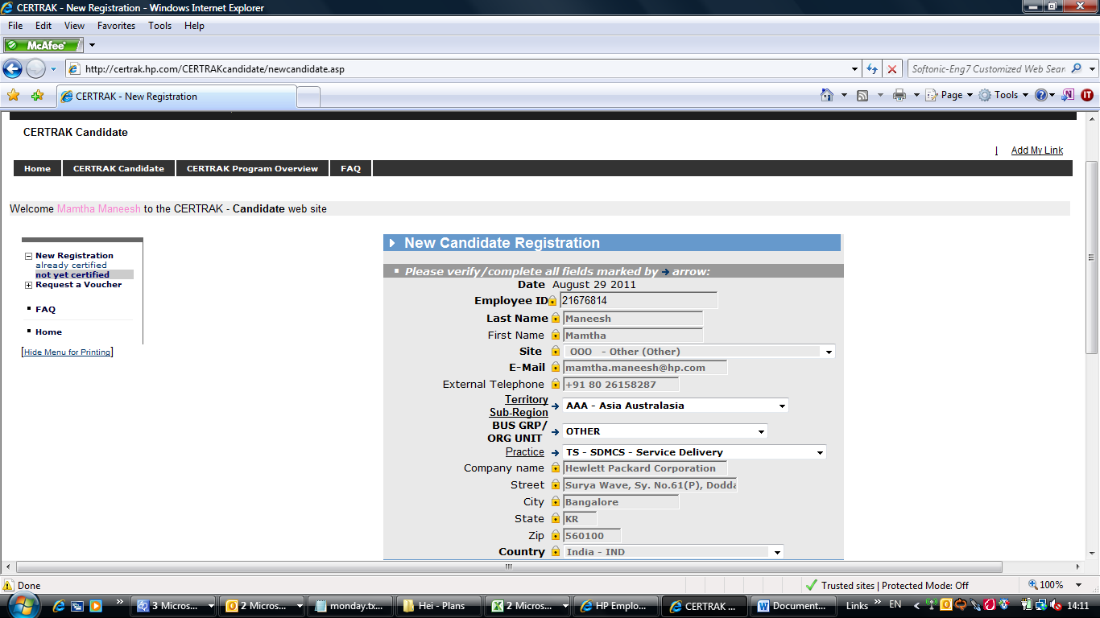

Step 4> Click on **Add this new approval**.

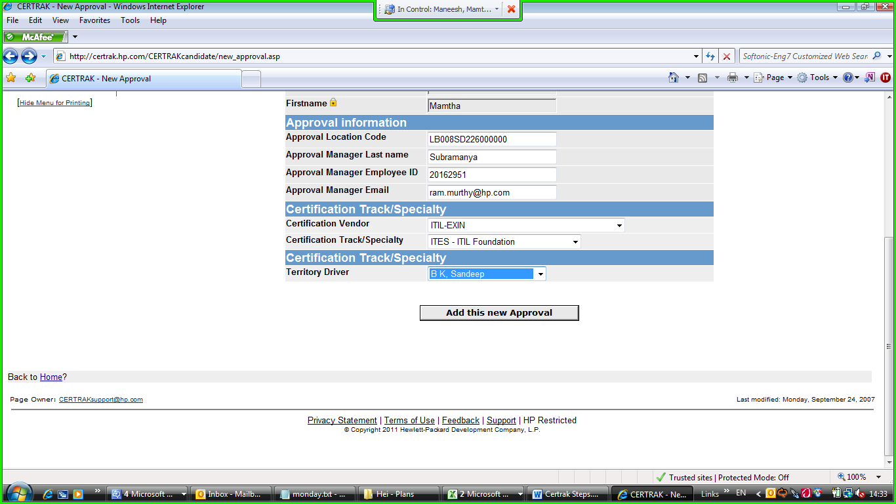

Step 5> It will go to the L&D team for verification.

Step 6> Once approved by L & D team **Sandeep B K** .You will receive a mail with the below link

<http://certrak.hp.com/CERTRAKcandidate/>

Step 7> Click on the link <http://certrak.hp.com/CERTRAKcandidate/> and below screen will appear.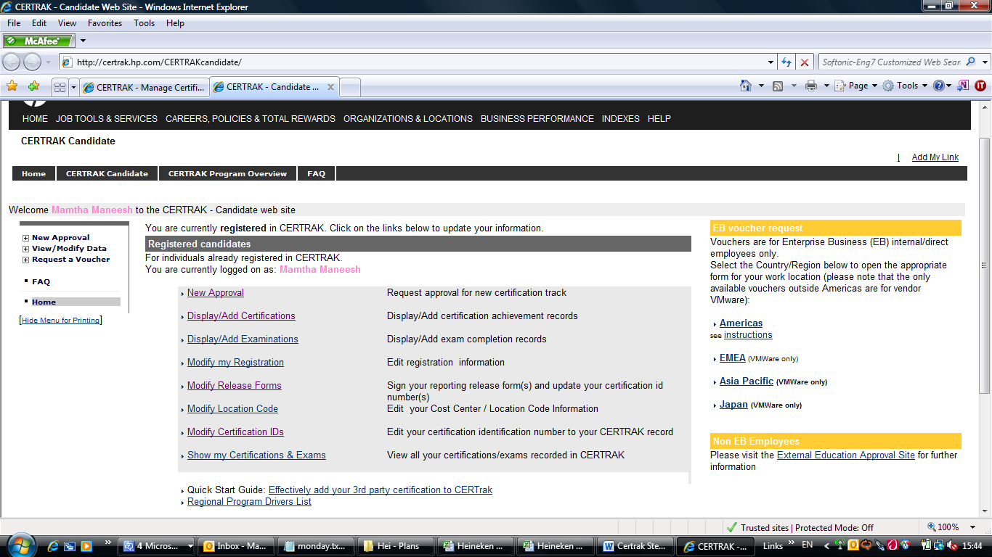

Step 8>Click on **Display /Add Certification** and Click on New

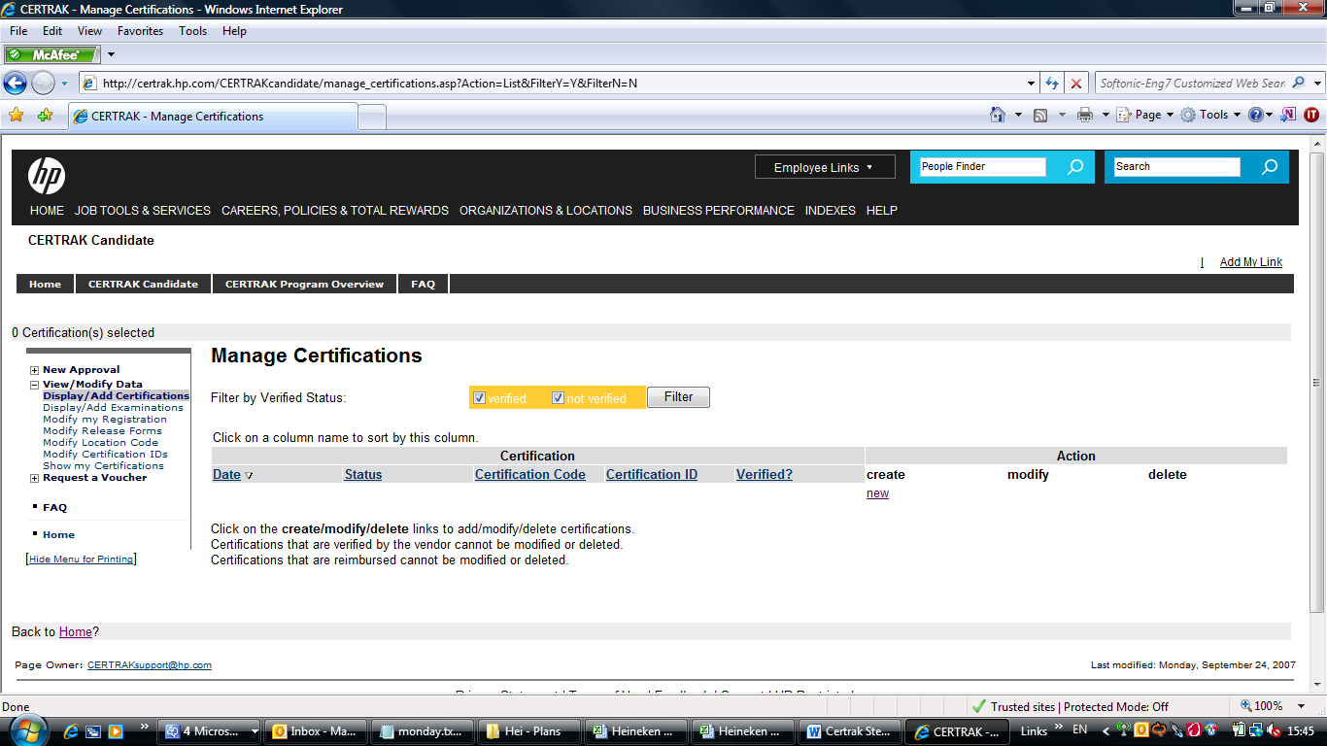

Step 9 > You will get the below screen to enter all your certification details, Please select all the correct details of your Vendor and the click on Add this new certification.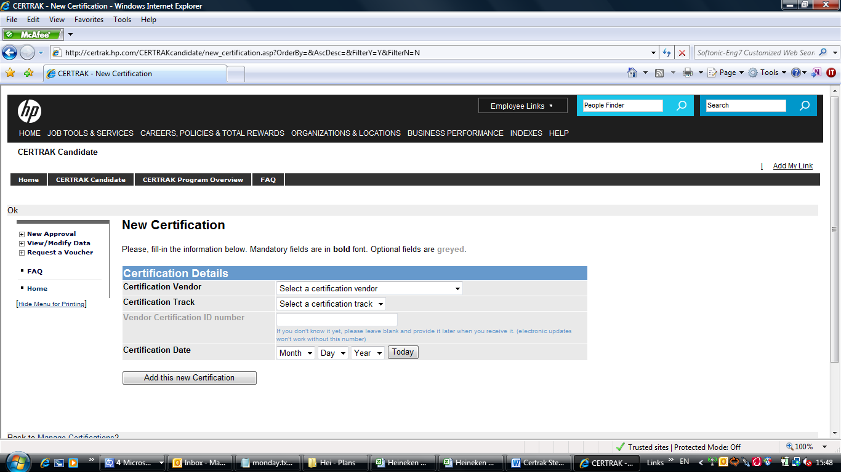

10> Once completed, it will again go to L& D team and they will verify with the Vendors.

Note: Team , You can follow same steps and update all your other certification details like

**PMP /Six Sigma / Cobit etc…..**